**PROJECT REPORT ON**

**AIRLINE MANAGEMENT SYSTEM**

**(DEVELOPER)-(LONG TERM)**

**Introduction:**

The project aim is to provide real-time knowledge for all the students who have basic knowledge of Salesforce and Looking for a real-time project. This project will also help those professionals who are in cross-technology and want to switch to Salesforce. With the help of this project they will gain knowledge and can include it into their resume as well.

**Milestone 01** -**CreatingDeveloper Org**

* Go to developer.salesforce.com
* Click on sign up.
* On the sign up form, enter the following details
* First name & Last name –pandita revathi
* Email :panditirevathi@gmail.com
* Role –SALESFORCE DEVELOPER
* Company – GAYATRI DEGREE COLLEGE – TIRUPATI
* Country - India
* Postal Code – pin code 517501
* Username – revathi@gdcproject.com

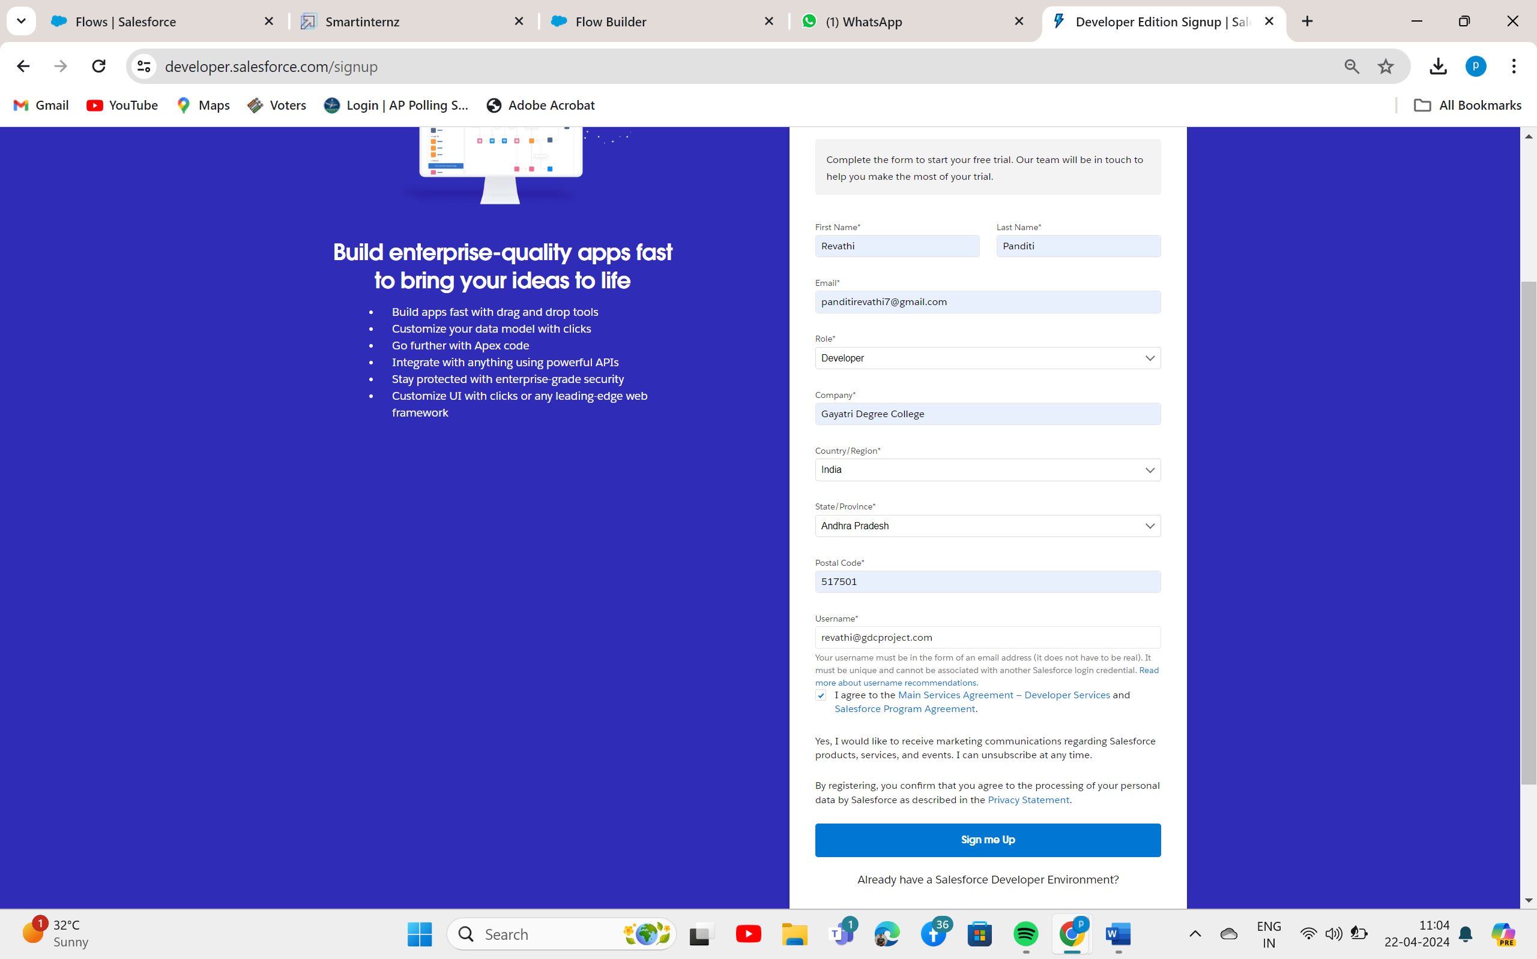

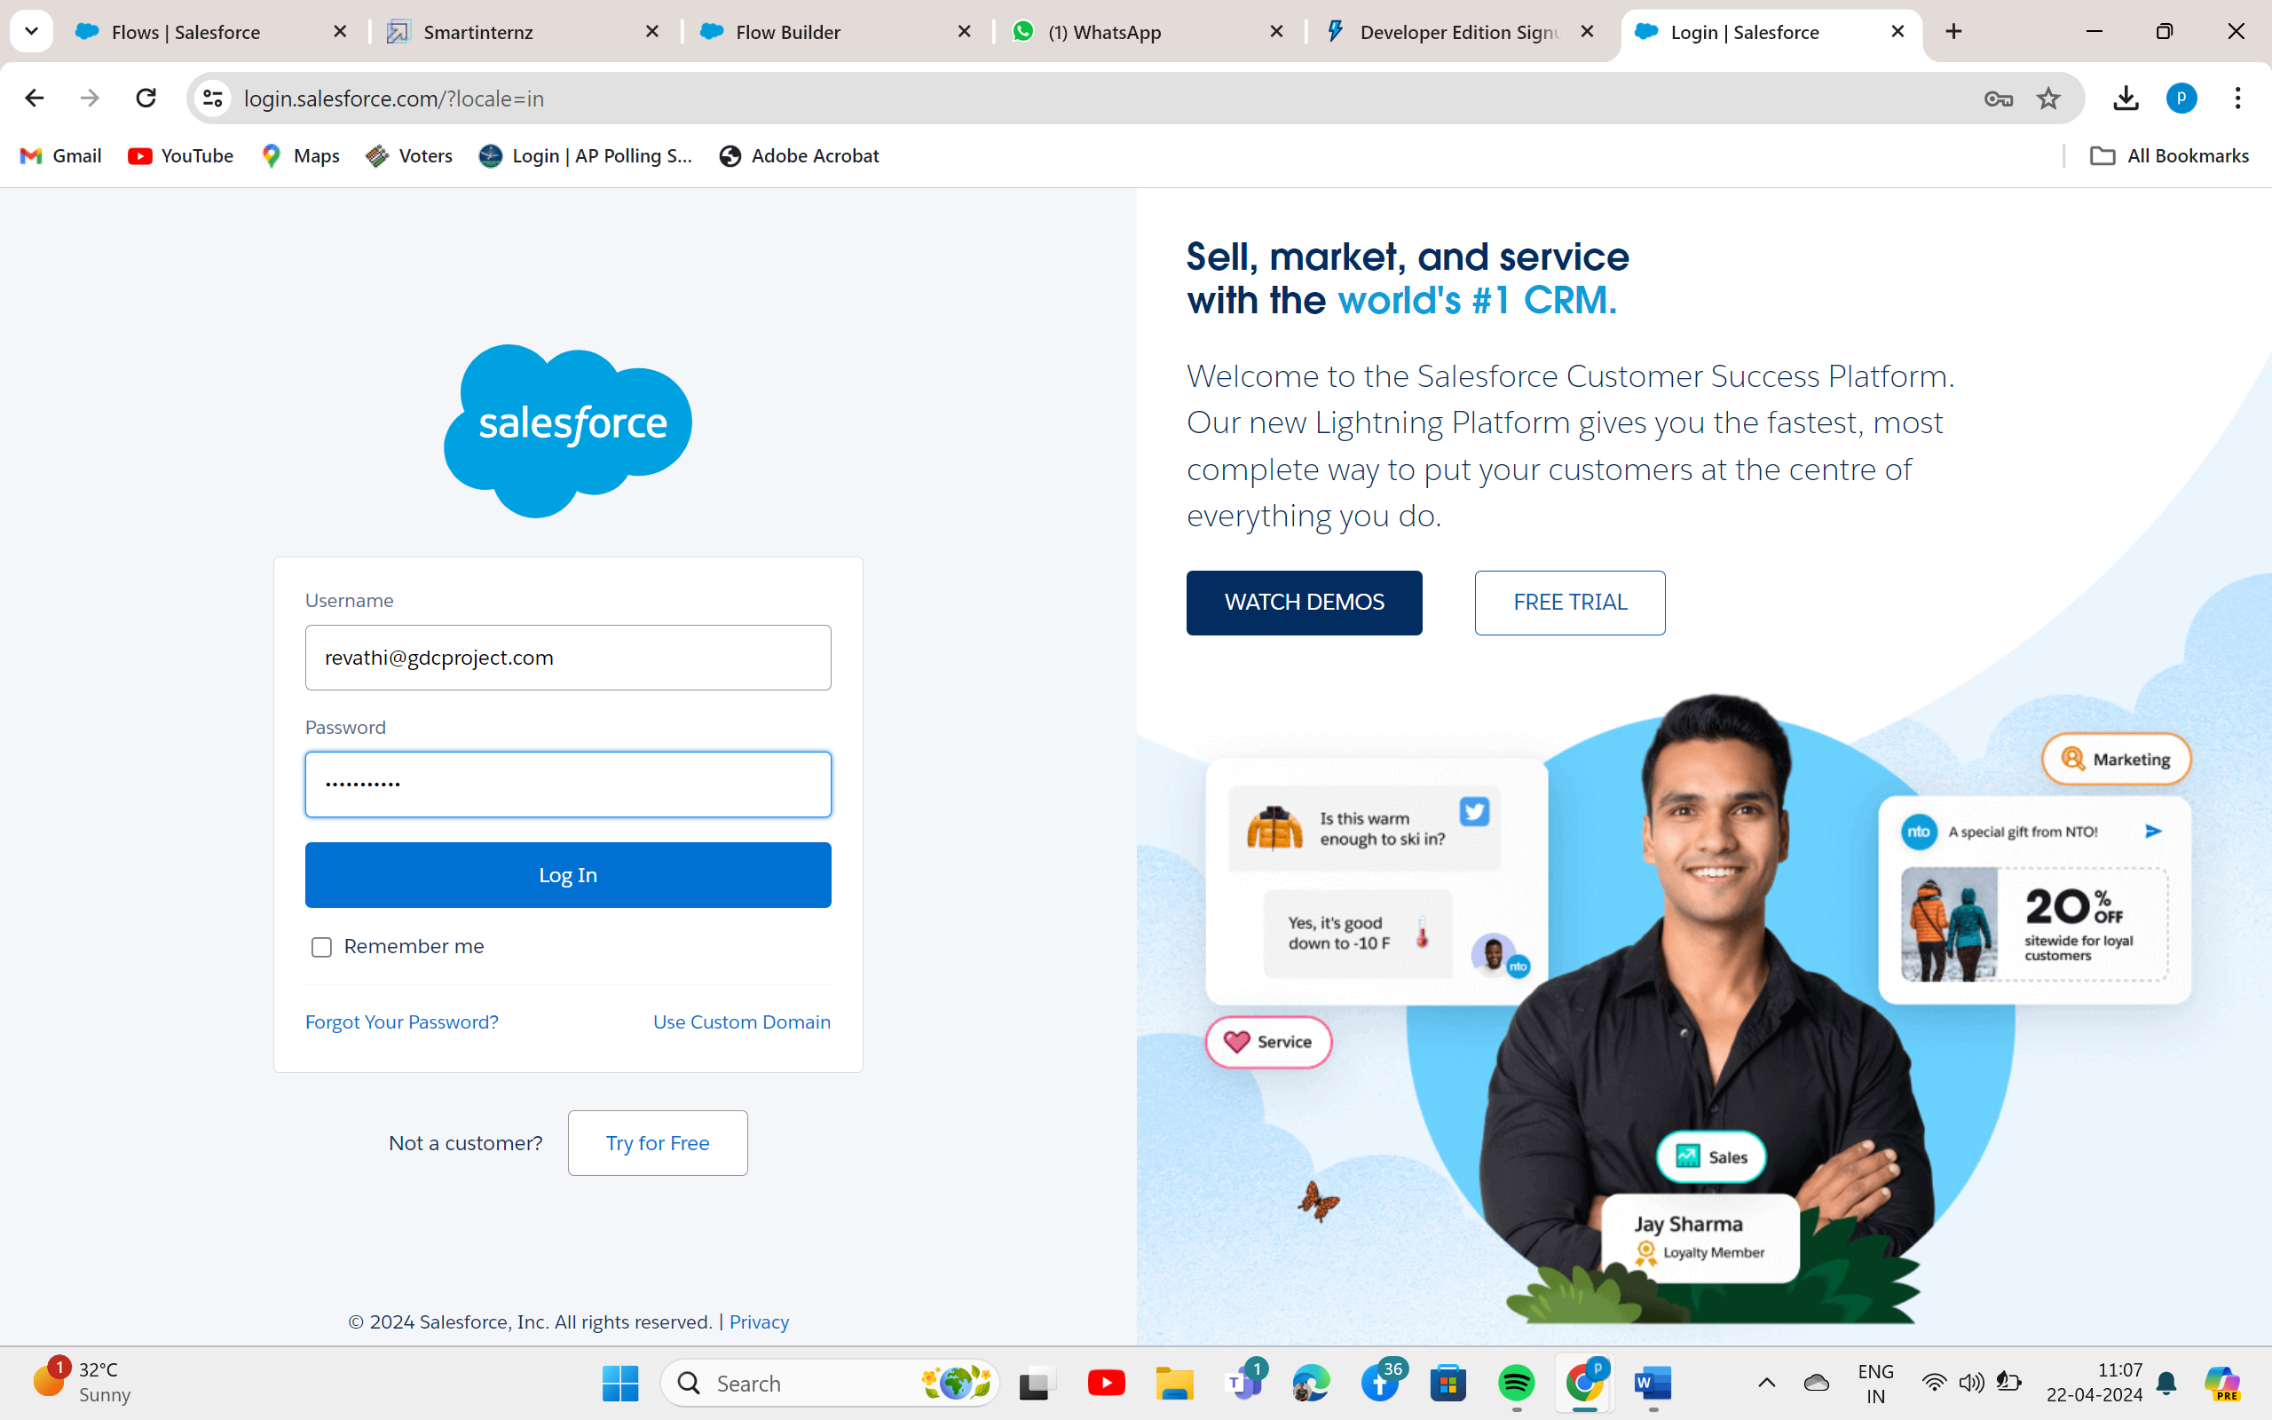

**Milestone 02 –Creation of Object**

## Use Case:

Creating an object in Salesforce organization is essential for efficient data management and process automation. By defining custom objects, businesses can structure and store data specific to their needs, enabling streamlined workflows, personalized reporting, and enhanced user experiences. Objects serve as the foundation for organizing and leveraging critical information within Salesforce. As an Admin for The Air India airlines, It’s your responsibility to store the data as per the organization needs.

Click on gear icon ? click setup.

To Navigate to Setup page:

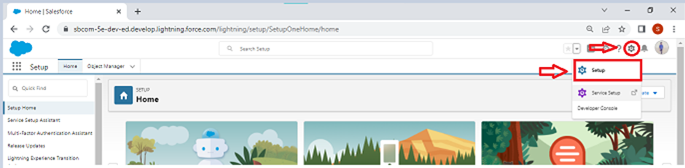

**Milestone 03 - Lightning App**

Go to setup page --> search “app manager” in quick find -->select “app manager” -->click on New lightning App.

1. Fill the app name in app details and branding as follow  
   App Name : AirLine Management System  
   Developer Name : this will auto populated  
   Description : Give a meaningful description  
   Image : optional (if you want to give any image you can otherwise not mandatory)  
   Primary color hex value : keep this default
2. Then click Next --> (App option page) keep it as default --> Next --> (Utility Items) keep it as default --> Next.

To Add Navigation Items:

1. Search the items in the search bar(Flight, Passengers, Booking, Crew, Reports, Dashboard) from the search bar and move it using the arrow button --> Next.  
   Note: select the custom object which we have created in the previous activity.
2. To Add User Profiles:

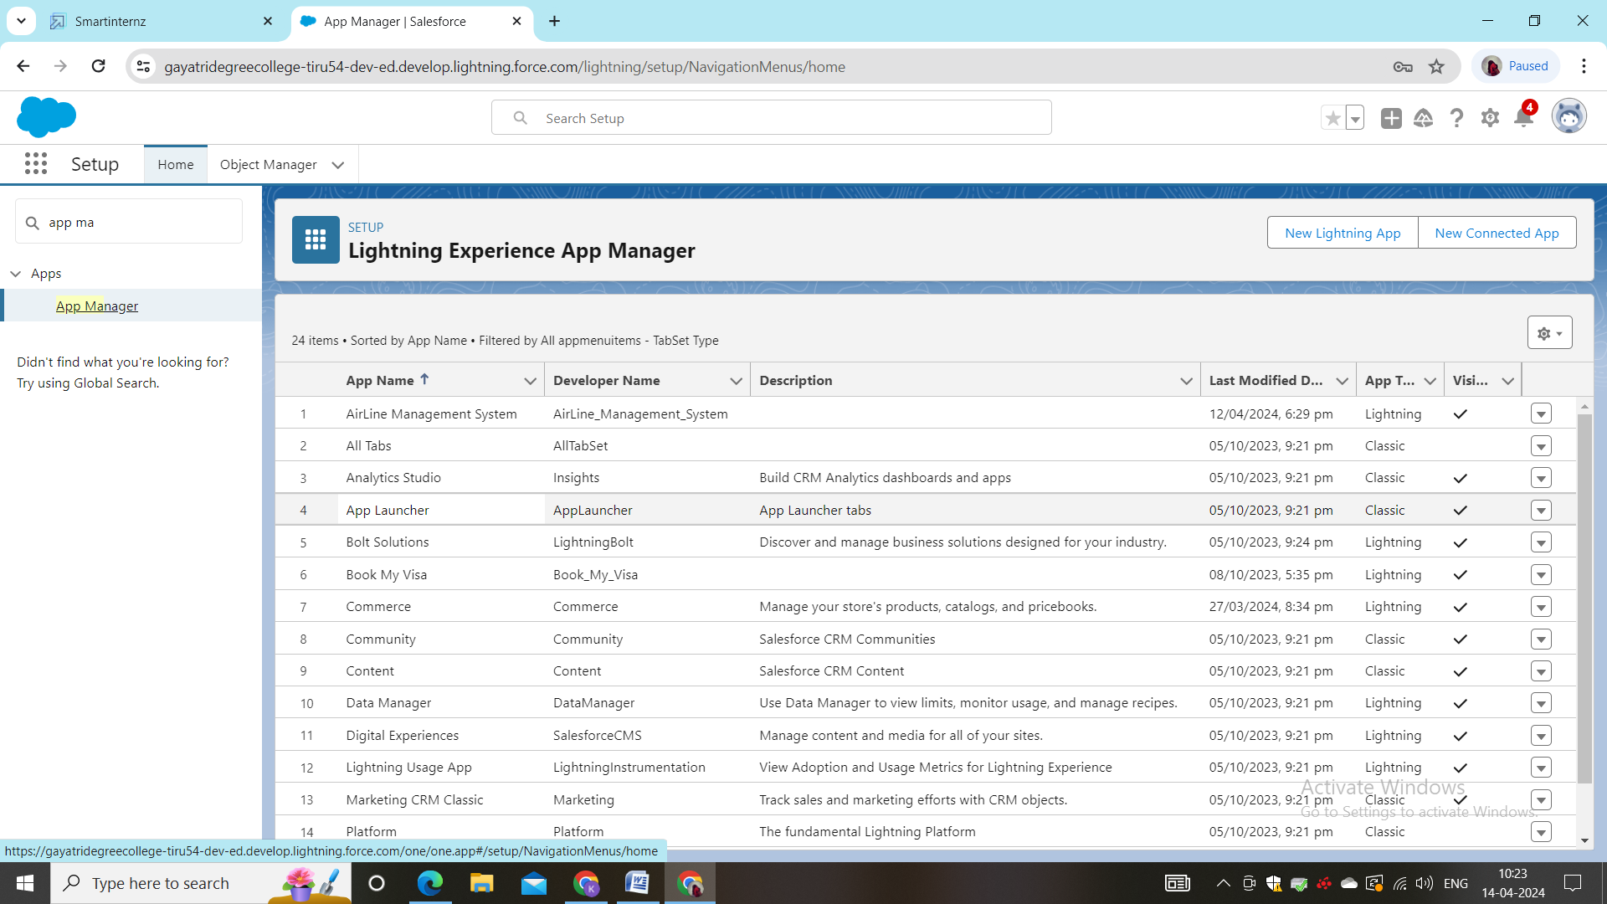

**Milestone 04 – Fields And Relationship**

Now it’s time for you to think out of the box for your organization. You have successfully created the database objects for the organization but now all eyes turn on you as you have to define what sort of information the objects store which you have created. As a life saver of your organization you come up with the idea of creating fields to store different types of data.

Go to setup --> click on Object Manager --> type object name(Flight) in quick find bar--> click on the object.

Now click on “Fields & Relationships” --> New

Select Data type as “Number”.

1. Fill the above as following:

* Field Label: Capacity
* Length : 18
* Field Name : gets auto generated
* Click on Next ? Next --> Save and new.

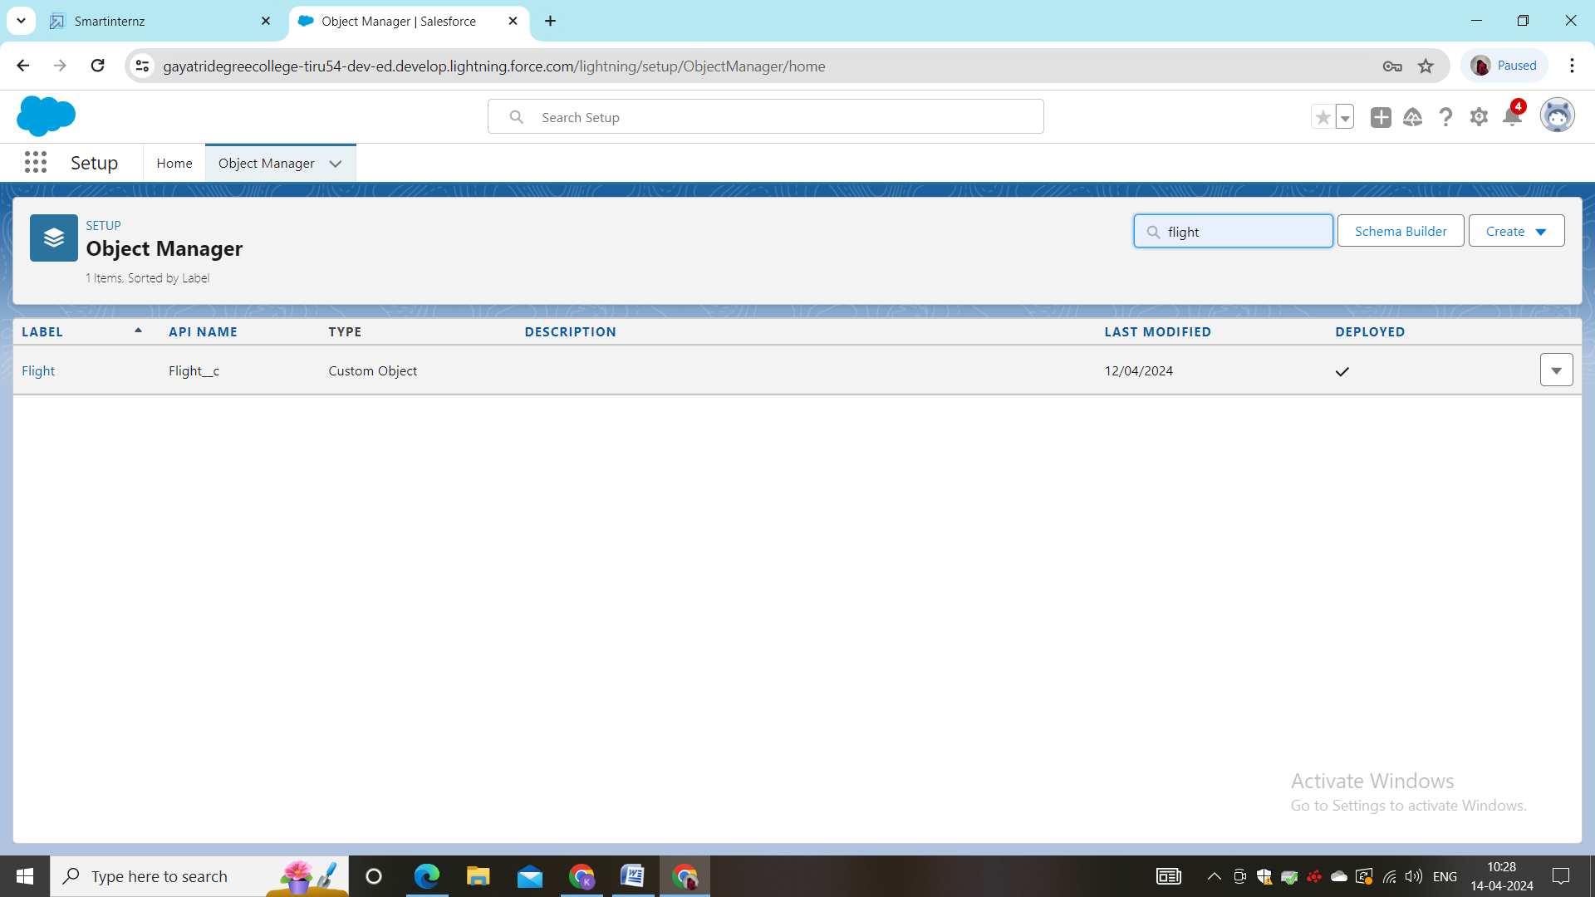

* **Fields in booking object**
* 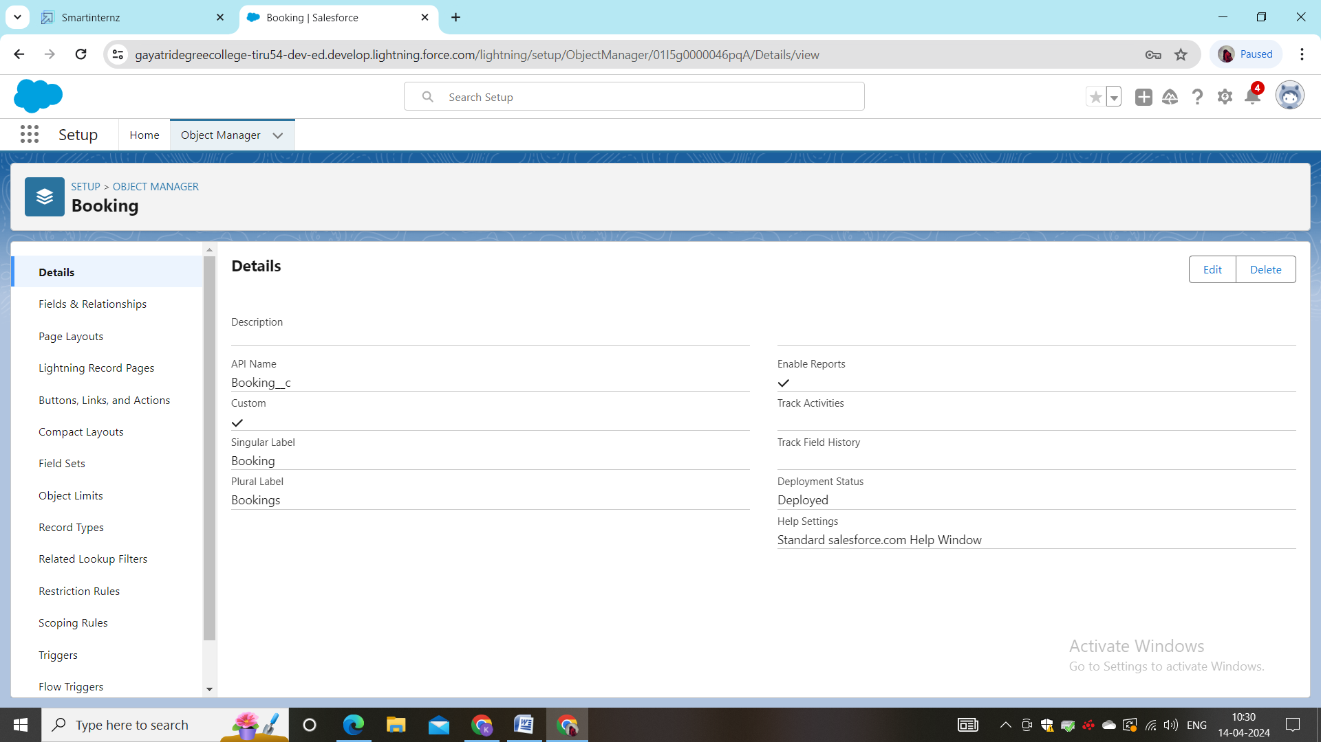
* **Fields in schema builder**
* 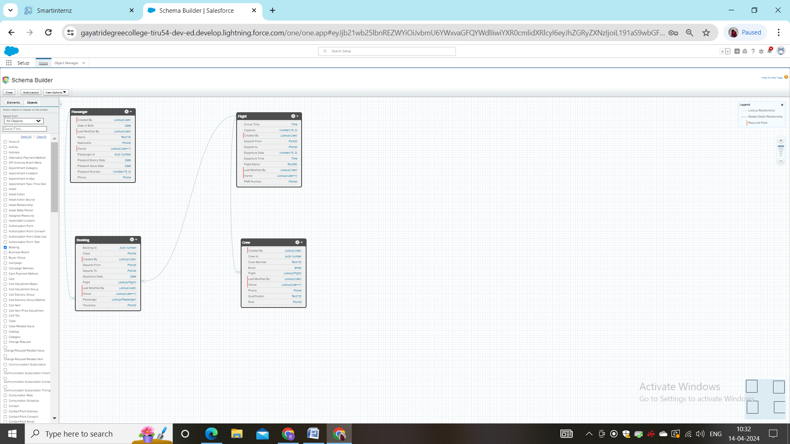

**Milestone 05 –user adportion**

* **Creation On Passangers object**

1. 1: Click on App Launcher on the left side of the screen.
2. Search AirLine Management System & click on it.
3. Click on App Launcher on the left side of the screen.
4. Search AirLine Management System & click on it.
5. Click on the Passenger Tab.
6. Click on any record name. you can see the details of the Passenger.
7. Click on App Launcher on the left side of the screen.
8. Search AirLine Management System & click on it.
9. Click on the Passenger Tab.
10. Click on Arrow at right hand side on that Particular record.
11. Click delete.

Create at least 10 records for each of the objects: Passenger, Booking, Flight, Crew.

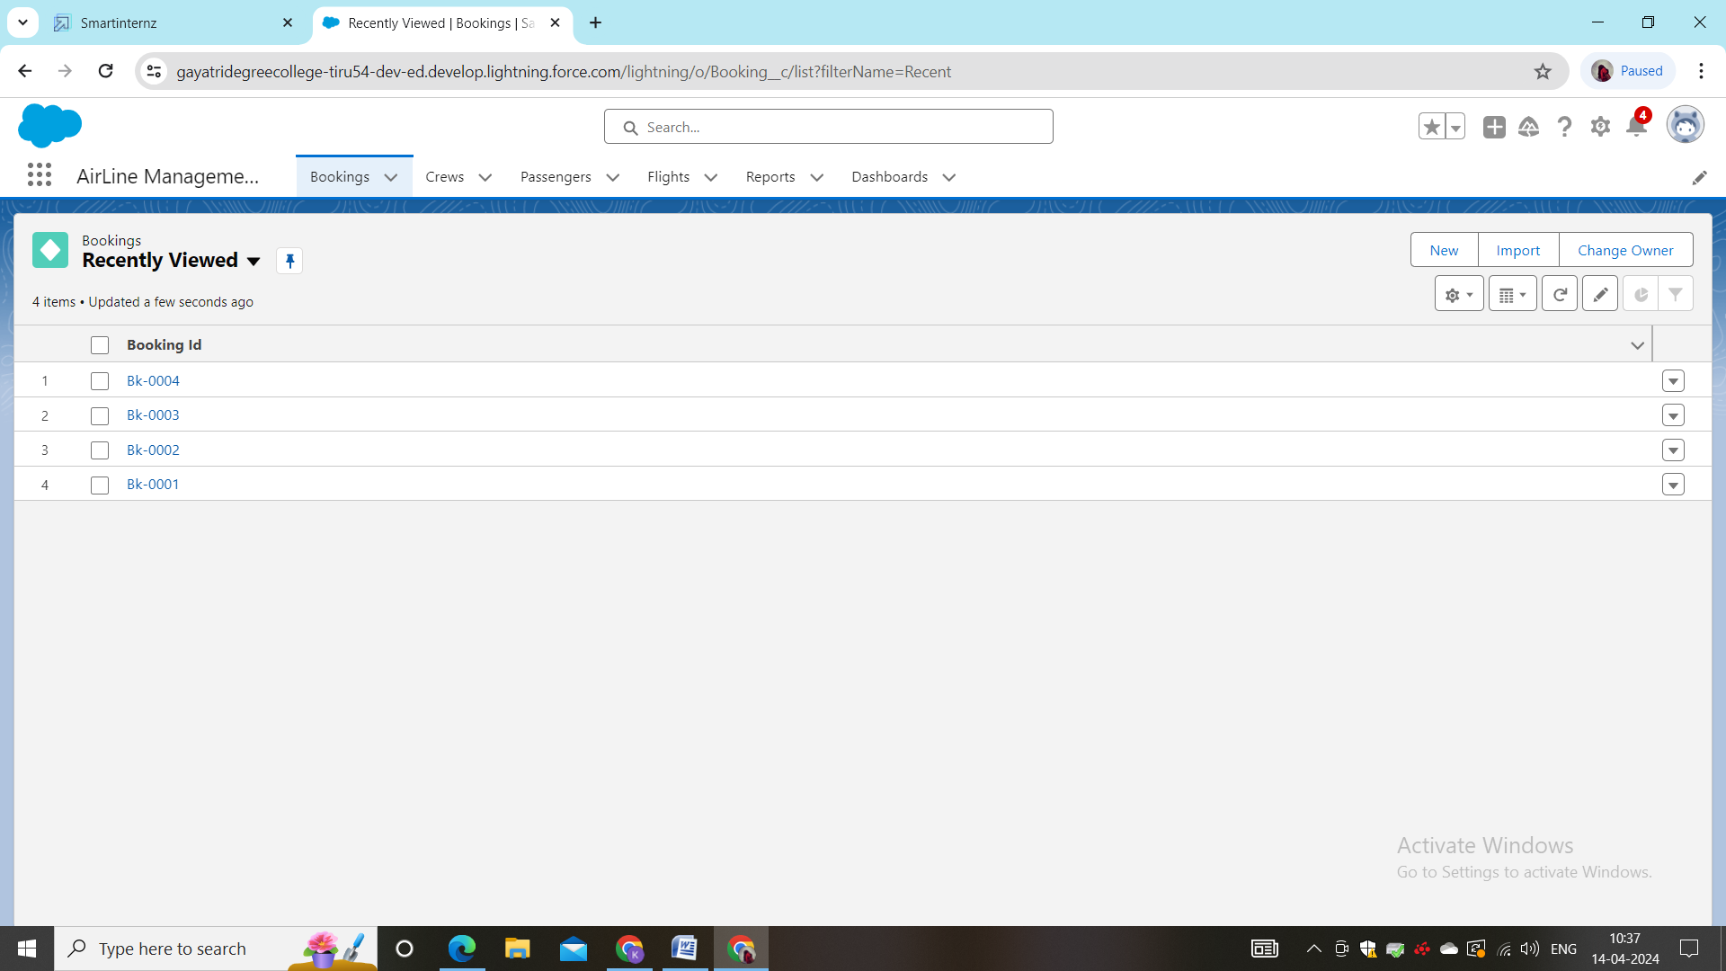

**Milestone 06 –profiles**

A profile is a group/collection of settings and permissions that define what a user can do in salesforce. Profile controls “Object permissions, Field permissions, User permissions, Tab settings, App settings, Apex class access, Visualforce page access, Page layouts, Record Types, Login hours & Login IP ranges. You can define profiles by the user's job function. For example System Administrator, Developer, Sales Representative.

## Types of profiles in salesforce

1. Standard profiles:

By default salesforce provides below standard profiles.

* Contract Manager
* Read Only
* Marketing User
* Solutions Manager
* Standard User
* System Administrator.

We cannot deleted standard ones

Each of these standard ones includes a default set of permissions for all of the standard objects available on the platform.

1. Custom Profiles:

Custom ones defined by us.

They can be deleted if there are no users assigned with that particular one.

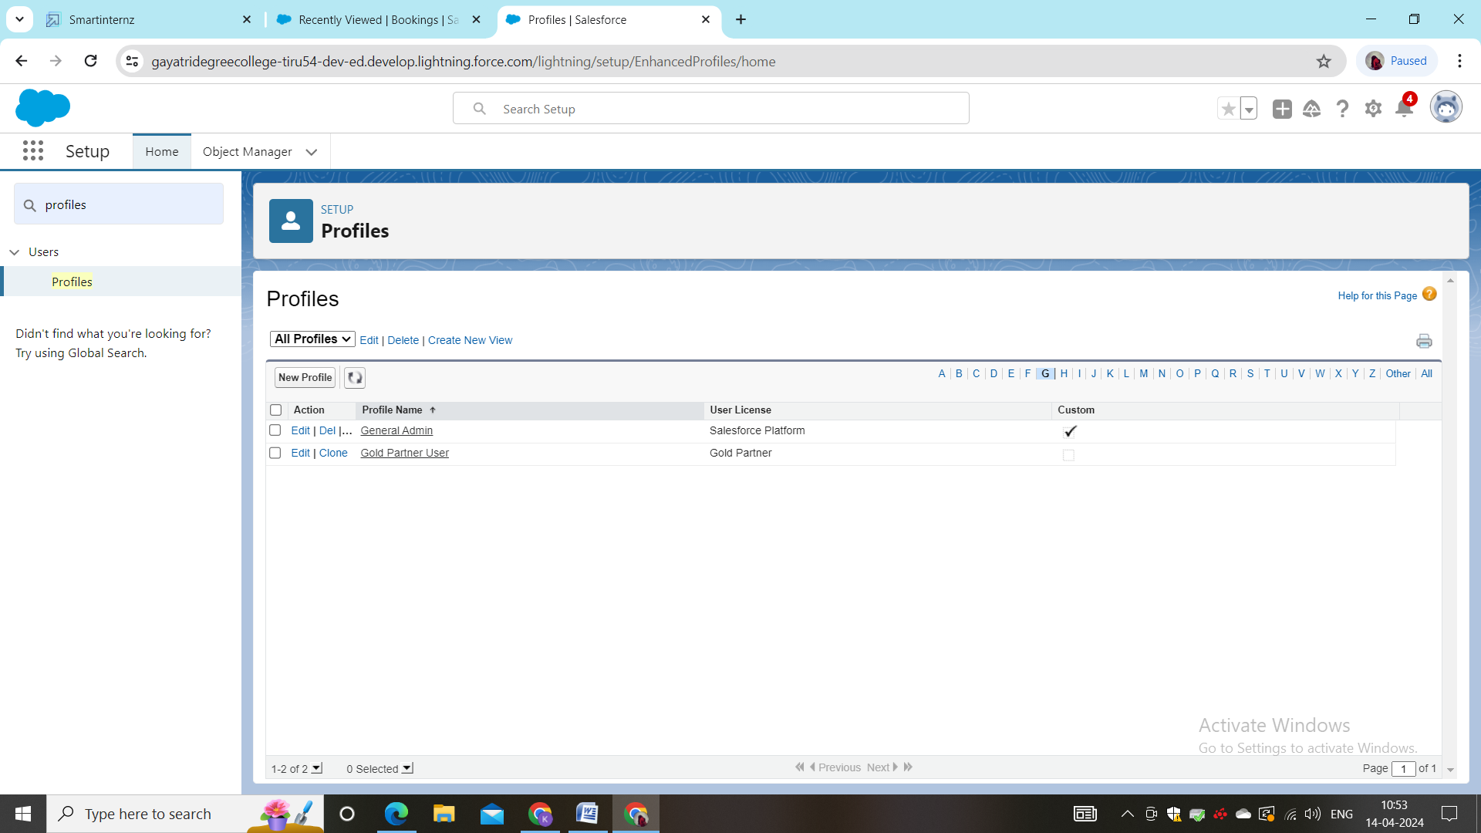

**Milestone 07 – Role**

1. **1:** Go to quick find --> Search for Roles --> click on set up roles.
2. Click on Expand All and click on add role under whom this role works.
3. Give Label as “Senior Admin” and Role name gets auto populated. Check to whom this role (Senior Admin) reports. Then click on Save.
4. Refer the below diagram to understand which role reports to which role.
5. Create three more roles for General Admin, Management Admin and Crew Member.
6. Note: Crew Members report to Management Admin, Management Admin & General Admin Reports to Senior Admin and only Senior Admin reports to CEO.

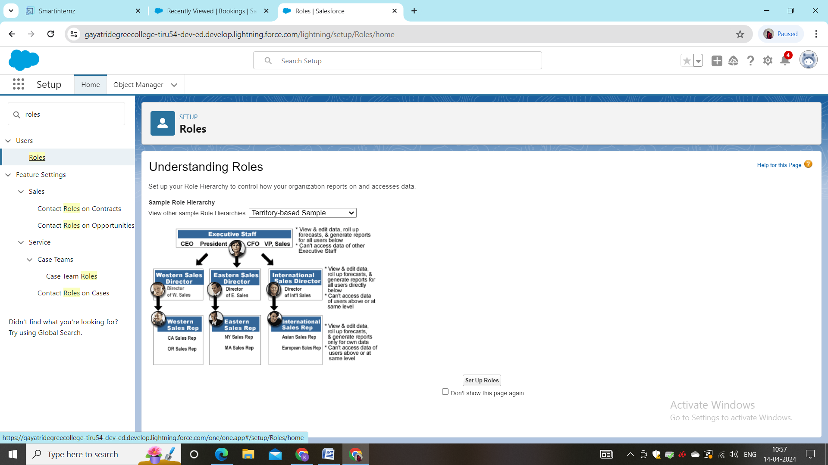

**Milestone 08 – Users**

A user is anyone who logs in to Salesforce. Users are employees at your company, such as sales reps, managers, and IT specialists, who need access to the company's records. Every user in Salesforce has a user account. The user account identifies the user, and the user account settings determine what features and records the user can access.  
  
Every user in Salesforce has a user account. The user account identifies the user, and the user account settings determine what features and records the user can access. Each user account contains at least the following:

* Username
* Email Address
* User's First Name (optional)
* User's Last Name
* Alias
* Nickname
* License
* Profile
* Role (optional)

**\*creatre user**

1. Go to setup --> type users in quick find box --> select users --> click New user.
2. Fill in the fields
3. First Name : Niklaus
4. Last Name : Mikaelson
5. Alias : Give a Alias Name
6. Email id : Give your Personal Email id
7. Username : Username should be in this form: text@text.text
8. Nick Name : Give a Nickname
9. Role : Senior Admin
10. User licence : Salesforce
11. Profiles : Senior Admin
12. Save.
13. 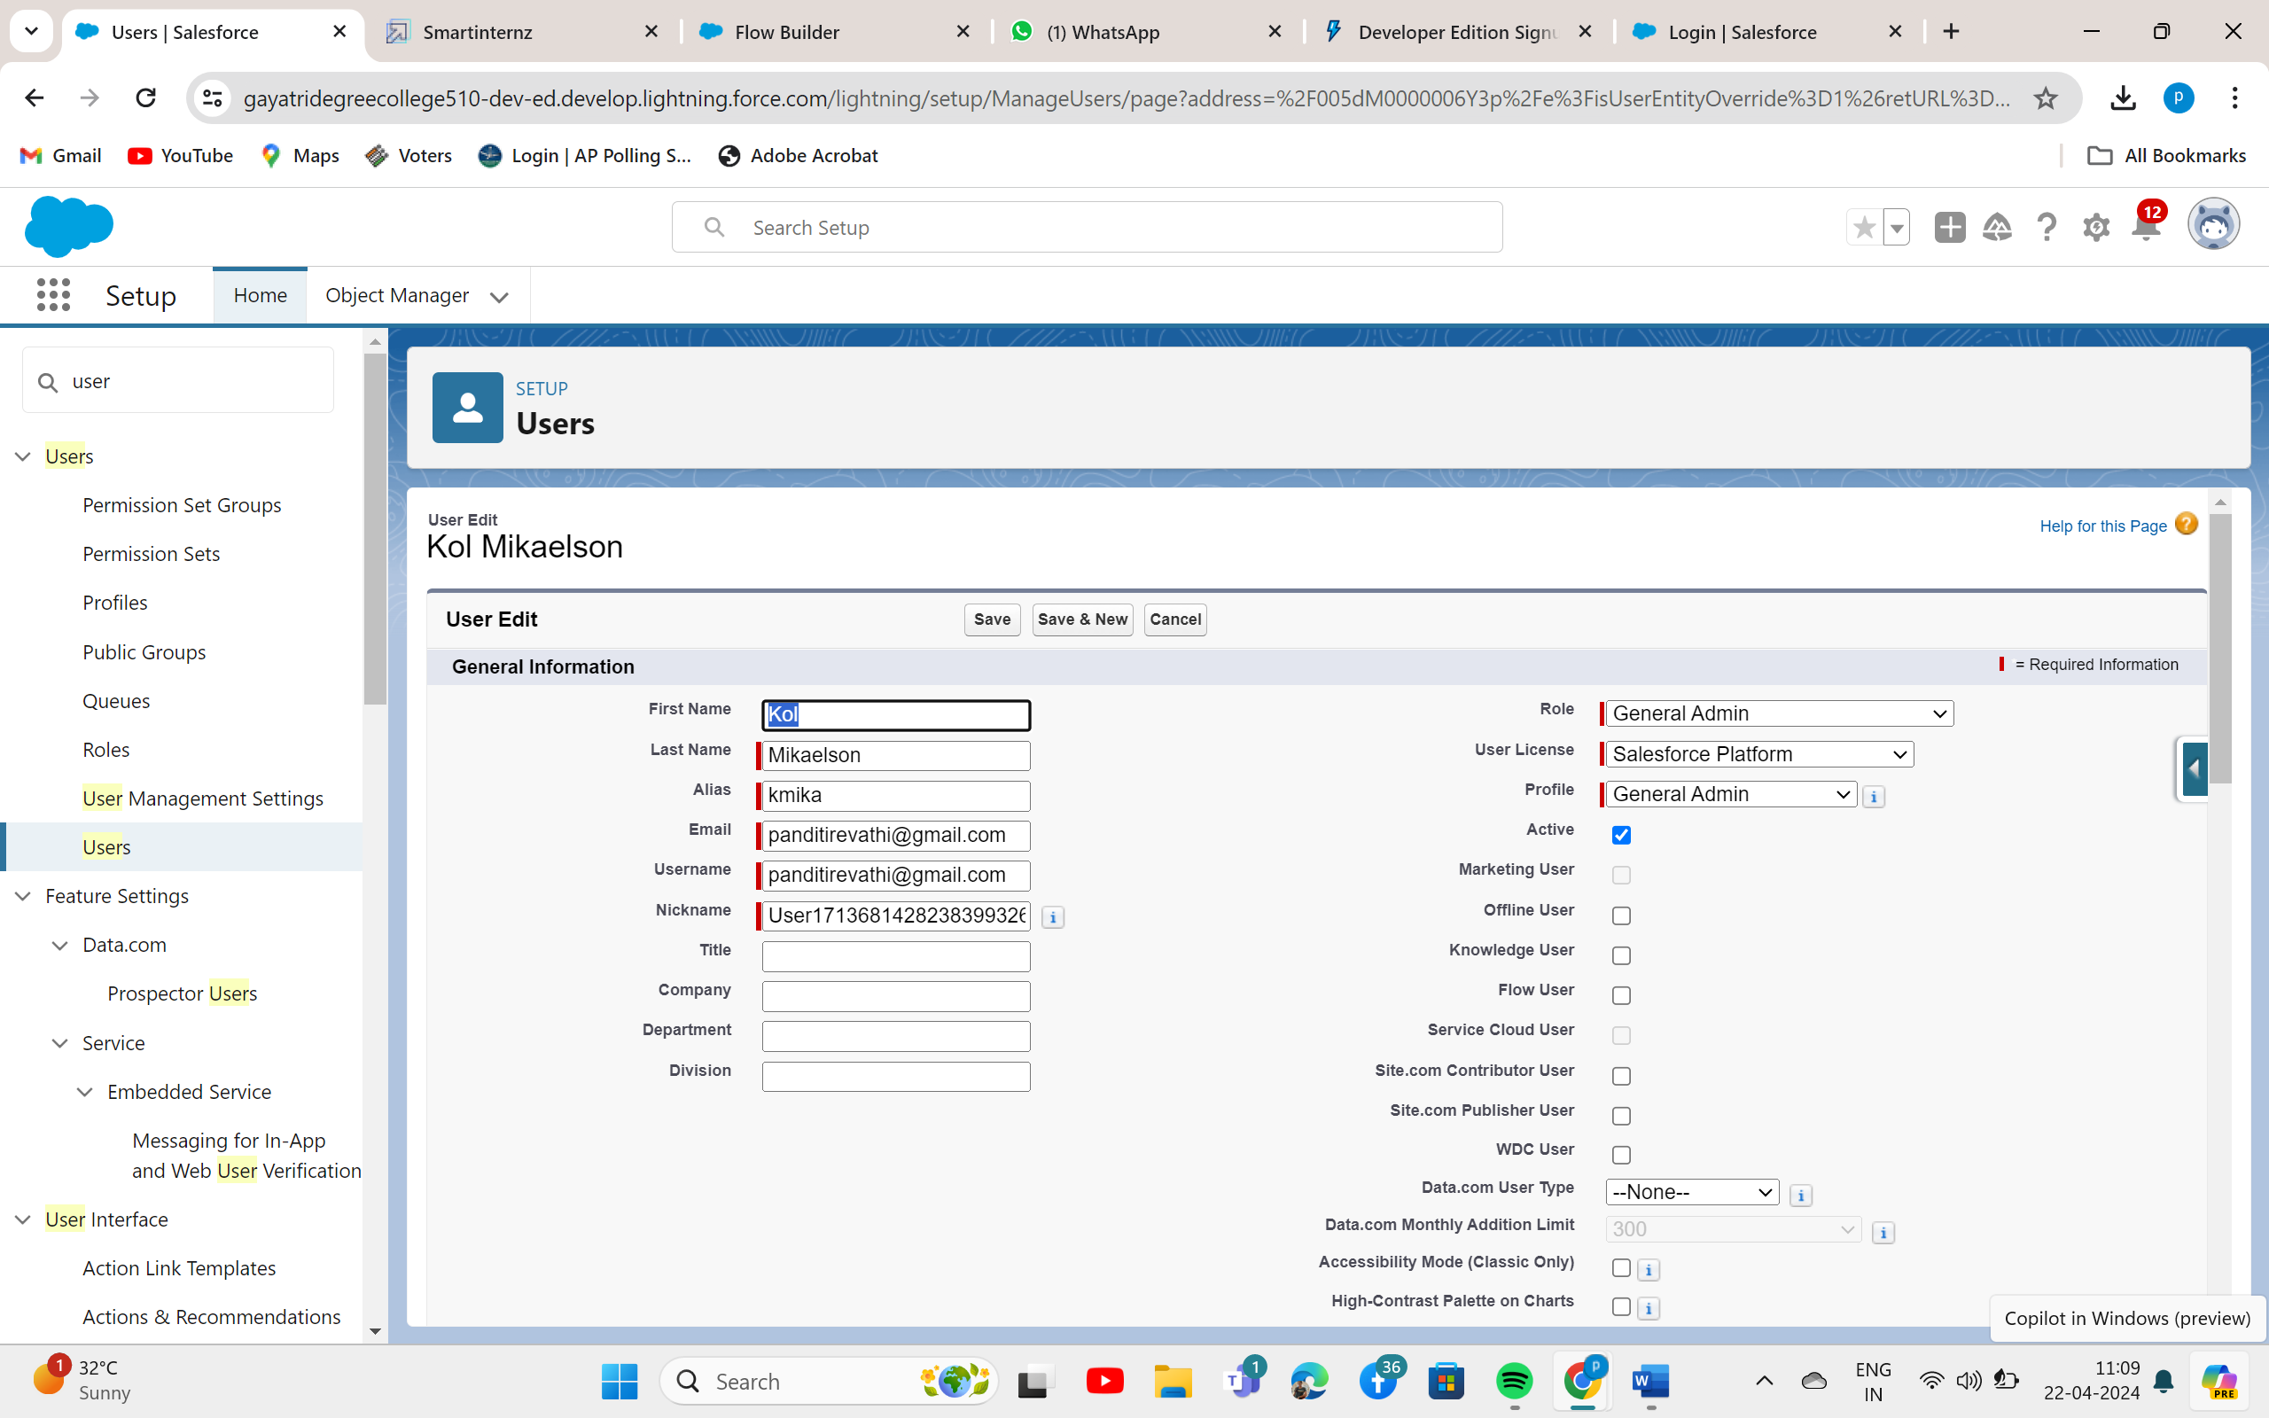

* **View Record (School)**

1. Click on App Launcher on left side of screen.
2. Search School Management App & click on it.
3. Click on Schools Tab.
4. Click on any record name. you can see the details of the School.

**Milestone 09 – Reports**

* **Create Report:**
* Go to the app --> click on the reports tab
* Click New Report.
* Select report type from category or from report type panel or from search panel --> click on start report.

1. Customize your report

* Check the toggle on the update preview automatically button.
* Add fields from the left pane as shown below.
* Add the “Traveller” field in Group Rows.
* Turn the toggle off for the subtotal button.

1. Click on save.
2. Save the report as “Bookings with Flight Details”
3. Click on Save.

* **View Report**

1. Click on App Launcher on left side of screen.
2. Click on Reports Tab.
3. Click on School with Students report and see records.

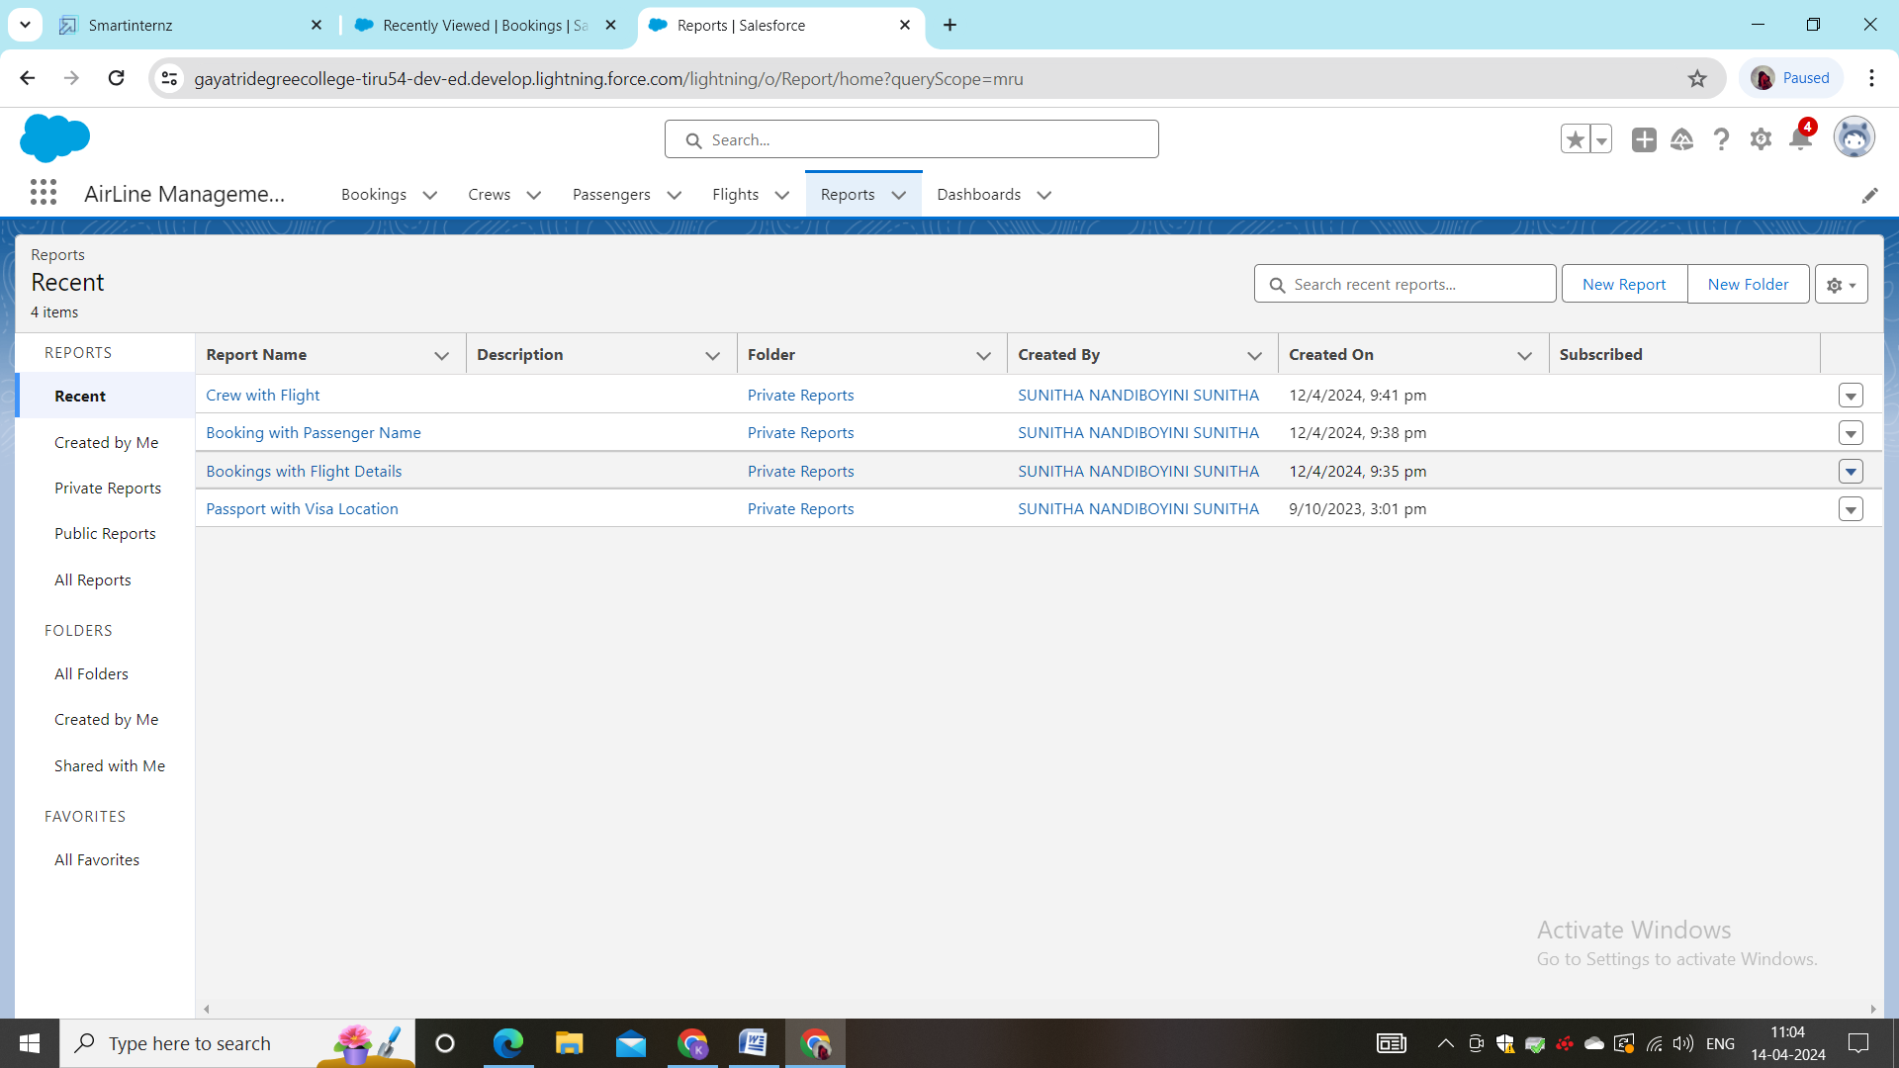

**Milestone 10 –Dashboard**

Create Dashboard

1. Go to the app --> click on the Dashboards tabs.

Give a Name and click on Create.

1. Select add component.
2. Select a Report and click on select.
3. Select the Donut option under display as and click on Add.

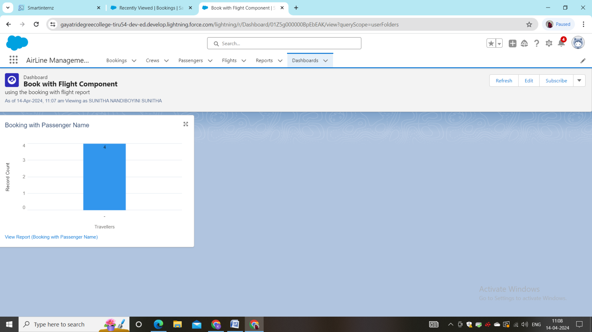

**Milestone 11 – Apex**

1. Go to Setup --> Click on the gear icon --> Select Developer Console..
2. Then we can see the Developer console. Click on the developer console and you will navigate to a new console window.
3. To create a new Apex Class follow the below steps:  
   Click on the file --> New --> Apex Class.
4. Give the Apex Class name as “PhnValid_PassengerObj”.
5. Click ok.
6. Now write the code logic here
7. 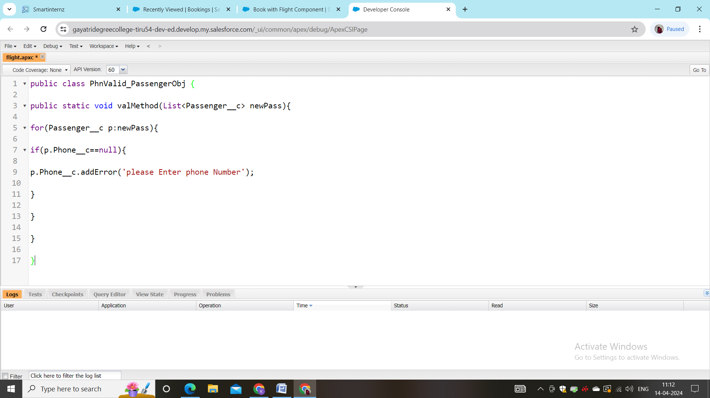

Milestone 12-Flows

*ceate a screen element on booking bject

1.From Setup search for the “Flows” in quick find and select “New Flow”.

Select “Screen Flow” and then click on “Create”.

1. Place the cursor in between the Start and End element, a “+” icon appears, click on that and select “Screen”.  
   Filling the fields as given below:
   1. API name : bookingObject
   2. Datatype : Record
   3. Object : Booking
   4. Available for input : Checked
   5. Available for output: Checked
2. Click on done
3. Once you are done with the creation of a resource with the name “bookingObject” go back to step 5 and click on the lookup icon and select “bookingObject” from the list.
4. After selecting “bookingObject” you’ll have all the fields which are in the object, drag and drop each field on the screen.
5. Your screen will look like as shown below:
6. Click on done and Save.
7. The flow will look like as shown below.

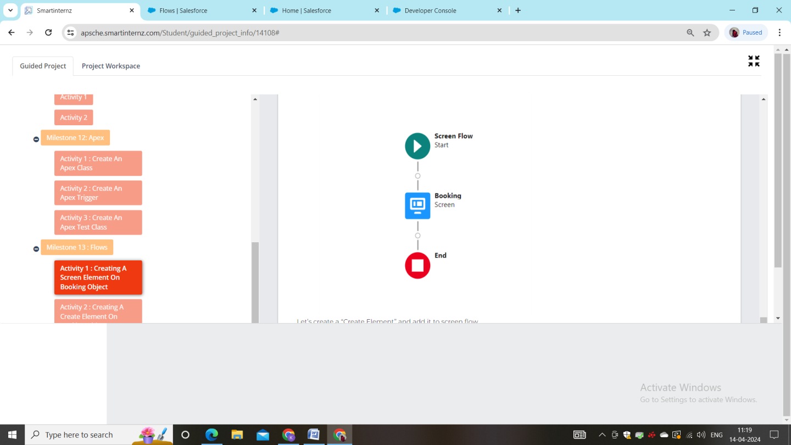

**The End**